# CS 255 System Design Document

## UML Diagrams

### UML Use Case Diagram

### UML Activity Diagrams

### UML Sequence Diagram

[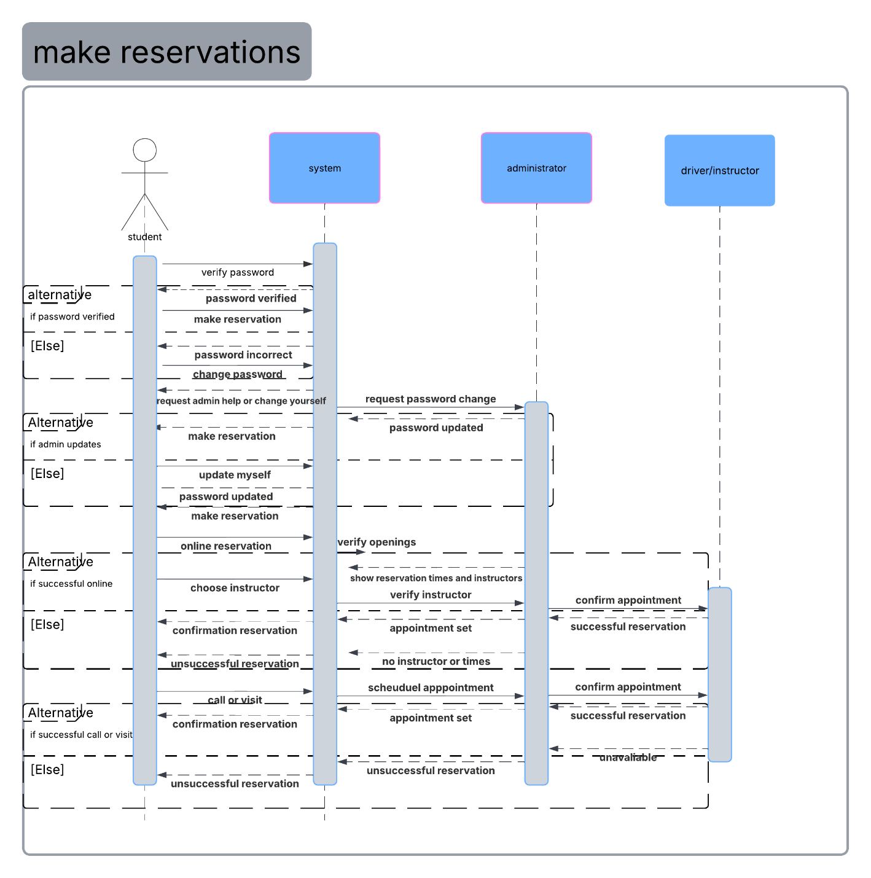](https://lucid.app/lucidchart/6559400b-4746-4b7d-b94c-e8097451bcfa/edit?crop=content&page=0&signature=8db493b0376b69b37c8241cbfe250f6b262d35c5ed7a28f35cd5966b4ac61d32)

### UML Class Diagram

*[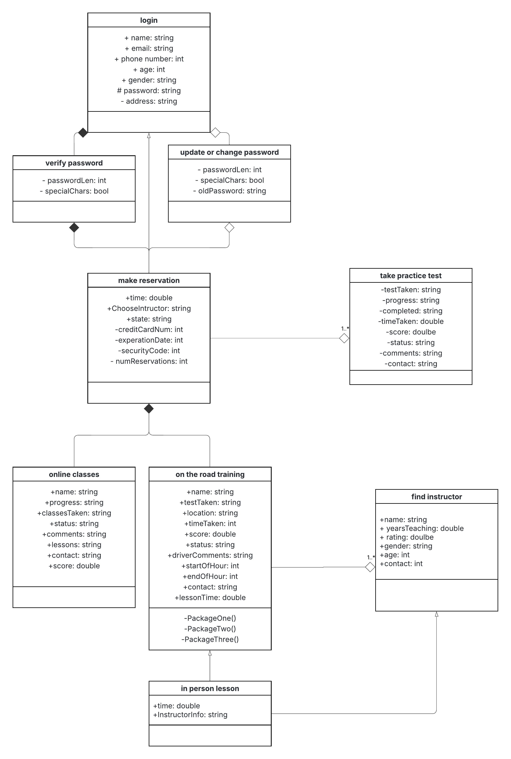](https://lucid.app/lucidchart/ee71c5fa-6d96-44fe-b1e8-a2acc37263c3/edit?crop=content&page=0&signature=353430ed4e418c655c26c3e05c8a4f1ef8ceac285a4e7bb3ccae80bd6aa3b133)*

## Technical Requirements

*While reviewing the functional and nonfunctional requirements for the DriverPass system, I will describe the technical requirements starting with the hardware side of things. For hardware, we will need user devices, cloud infrastructure, database server, and an IT/Admin workstation. This will include things like user devices such as a phone, tablet, computer, laptop, etc. A cloud to work off to support the uptime and scalability, as well as making it accessible off the internet. A database server to store the user’s data such as login information, test and reservation information. We will also need a backup and recovery system as they mentioned they want to be able to reset, cancel, and modify the user’s information. This will also help ensure data is safe. IT or Admin workstation will help the administrators have clear access to the dashboard.*

*For the software side of things were going to want a web server, relational database, authentication modules, responsive web interface, mobile compatibility, validation system, encryption system, firewall, DMV notification system, payment gateway integration system. This will ensure the users’ experience as well as the user’s safety and security are all in check in order for the system to run smoothly, securely, and provide good user experience.*

*Lastly, regarding the geographical requirements, we are going to want to have an in-person office for driving lessons, and registration. As well as for the secretary, drivers and instructors, and administrators to work out of, and store the vehicles at. Cloud deployment, this should be supported regionally. User access must also be accessible through all U.S. states with consideration for time zones (for scheduling purposes), and DMV updates. Also, language and accessibility. English interface with ADA-compliant design for accessibility.*

*These are the technical requirements for the DriverPass system that we have designed. These requirements can change through time and maintenance stages of development. But with the business requirements that we have laid out, these are the technical requirements that we will begin to implement.*